Research

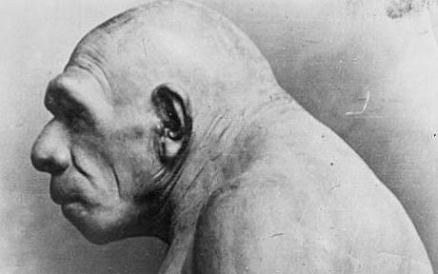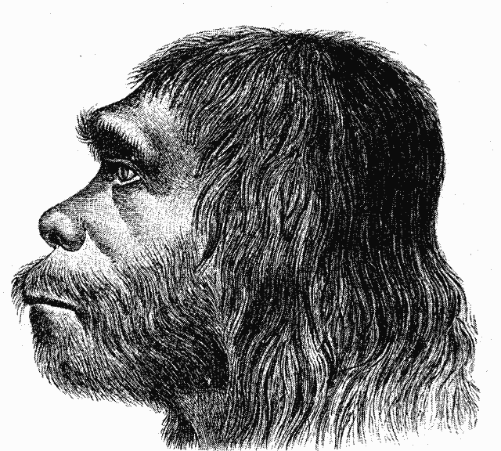

Sources below: The Daily Telegraph online newspaper.

Neanderthals had more sophisticated diets than previously thought

Neanderthals ate seafood and had sophisticated palates
Harp seal: Neanderthals had more sophisticated diets than previously thought

By Roger Highfield, Science Editor 10:03PM BST 22 Sep 2008

Neanderthals clubbed seals and ate dolphins and other seafood to survive in what was thought to be their last holdout before they were driven to extinction.
Scientists close to cracking Neanderthal DNA code
Were Neanderthals our enemies or lovers?
Neanderthal tools reveal advanced technology

The evidence that they had more sophisticated tastes than their caveman image, dining on seafood, suggests comes from Gibraltar, from Vanguard Cave and Gorham's Cave, where the last group ended up some 26,000 years ago.

This was the last of a mighty Neanderthal (Homo neanderthalensis) empire that once stretched from Asia to Western Europe from as much as 300,000 years ago, thriving on the cold of ice ages in woodlands where they hunted with heavy spears.

While their lives in the north were dominated by reindeer, woolly mammoth, and so on, an analysis of remains in Gorham's and Vanguard Caves, located at Governor's Beach on the eastern side of the Rock provides evidence they ate molluscs (mussels), seal, dolphin, and fish over some 50,000 years.

The research is published in the Proceedings of the National Academy of Sciences by Prof Chris Stringer at the Natural History Museum, working with Prof Clive Finlayson of the Gibraltar Caves Project, and colleagues.
Related Articles
Neanderthals could have died out because their bodies overheated 20 Dec 2008
Neanderthals were not ugly because of the cold, new research finds 16 Jan 2011

'Recent work on Neanderthals and the isotope signatures in their bones suggested they were heavily dependent on meat from land animals such as horse and deer, whereas early modern humans had a much broader diet, including birds and fish,' explained Prof Stringer.

'We already knew that Neanderthals were heavily carnivorous from sites further north in Europe, but now we have evidence that along the Mediterranean coast they also exploited marine foods, in a similar way to modern humans.'

Neanderthals ate marine mammals such as the monk seal (Monachus monachus) and dolphins (Tursiops truncatus), and probably also fish such as sea bream. Remains of shellfish such the mussel (Mytilus galloprovincialis) were also discovered. As for oysters, "not as far as we know, but it is possible," said Prof Stringer.

'The seal bones we found have clear cut marks and peeling, from Neanderthals bending and ripping them from the body to remove meat and marrow. The mussel shells had been warmed on a fire to open them,' said Prof Stringer.

'Since we have recurrent evidence from several excavated levels over 30,000 years old in the two Gibraltar sites, we can say that eating seafood was not a rare behaviour for Neanderthals.

"We have found evidence that they knew the geographic distribution and behaviour of their prey, suggesting they were hunting on a seasonal basis.'

Intriguingly, the way that Neanderthals butchered seals can be seen today among Inuits, who cut the flippers off at the joints, and draw the skin off in a single piece.

The fore flippers - with the shoulders and the hind flippers - are taken out, the only part remaining being the head, the spinal column, and the rump bone.

The team thinks there was seasonal hunting practices at a time when seals would be vulnerable because of their need to breed on land. Dolphins can also seasonally become beached on the seashore, where they can be scavenged.

The caves also contain hearths and flint stone tools, as well as butchered land mammals such as ibex (Capra ibex), red deer (Cervus elaphus), wild boar (Sus scrofa), bear (Ursus arctos) and rabbit (Oryctolagus cuniculus).

Given the diverse diet, "it may therefore be no coincidence that they survived longest in this part of the world," said Prof Finlayson.

A typical Neanderthal was shorter than a modern European with a heavy trunk and a robust and powerful build - perfect for his Ice Age environment.

And he had a big brain too: it is thought possible that he used body decoration, hunted in packs and - by one analysis - had a shorter and wider vocal tract than a modern male human's that could manage the complex range of sounds needed for speech, albeit at higher pitches.

The two leading theories of why Neanderthals were wiped out was that our ancestors outcompeted them for resources or exterminated them.

"There is a third which I advocate, which is that climate and chance events fragmented the Neanderthals over a long period - in other words we had nothing at all to do with it," said Prof Finlayson.

Neanderthals could have died out because their bodies overheated

Neanderthals may have died out because their bodies overheated as the Earth grew warmer, according to new research.
By Richard Gray, Science Correspondent 11:06AM GMT 20 Dec 2008

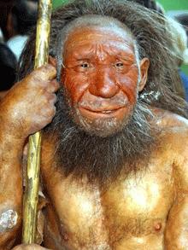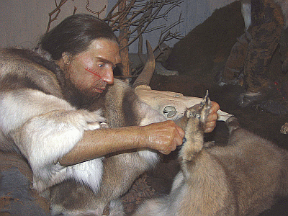

Analysis of DNA obtained from Neanderthal remains has revealed key differences from modern humans that suggest their bodies produced excess heat.
Neanderthal DNA reveals key differences from modern humans

While in the cold climate of an ice age this would have provided the species with an advantage, as the earth warmed they would have been less able to cope. Ultimately this would have caused their extinction around 24,000 years ago.

Scientists at Newcastle University have put forward the theory after examining a particular form of genetic material which was obtained from the fossilised bones of Neanderthals.

By comparing it with that found in modern humans, they discovered that Neanderthals had key differences in the sections responsible for producing energy in all living cells.

Professor Patrick Chinnery, a neurogeneticist at Newcastle University, believes the differences in this mitochondrial DNA could have caused Neanderthals to be inefficient at producing energy, meaning their cells leaked heat.
Related Articles
Neanderthals were not ugly because of the cold, new research finds 16 Jan 2011
Neanderthals speak for first time in ten millennia 16 Apr 2008
Neanderthals ate seafood and had sophisticated palates 22 Sep 2008

He said: "The question is why did Neanderthals disappear? There are lots of explanations to do with changes in climate and the food supply.

"Differences in these mitochondrial DNA sequences might explain why modern humans were able to survive while Neanderthals were not.

"We compared mitochondrial DNA sequences from Neanderthals that have been obtained by other researchers with a huge database of human sequences from around the world to see how different it was from modern humans.

"We found a number of differences within a certain part of the mitochondrial DNA that were quite unlike anything we see in modern humans.

"It is difficult to get a definitive answer, as it is rather like looking through a misty window. We can only get clues to what went on."

Mitochondria are tiny structures found inside all living cells and are the biological power stations that produce the energy cells need to survive by converting sugar from food into energy.

The research by Professor Chinnery, which was recently presented at a conference held by the American Society on Human Genetics, is the latest attempt to find out why our ancient cousins died out.

Scientists have also been attempting to read the entire Neanderthal genome in the hope that it will shed more light on the differences between them and modern humans.

Recent work by scientists at the Max Planck Institute in Germany revealed that Neanderthals shared a language gene that is only found in modern humans. The controversial findings raised the debate about whether Neanderthals were capable of speech.

Neanderthals are thought to have evolved from a common ancestor shared with modern humans around 400,000 years ago. It is thought they died out around 10,000 years after modern humans began spreading in to Europe.

There is a great deal of debate about what actually sealed Neanderthals fate, with the changing climate, dwindling food supplies and modern humans themselves all being blamed for killing the species off.

Neanderthals were not ugly because of the cold, new research finds

The characteristic broad foreheads and large noses of Neanderthals did not give them any special advantage in the cold arctic conditions of the last ice age, according to new research that has raised new questions about the habitats our prehistoric relatives lived in and why they died out.
The remains of Neanderthals are found across Europe and in western and central Asia Photo: ALAMY
By Richard Gray, Science Correspondent 8:00AM GMT 16 Jan 2011

34 Comments

Their prominent facial features have caused them to be cast as one of nature's less attractive creatures, but now one of the main scientific explanations for Neanderthals' large noses and jutting foreheads has been disproved.

For more than 150 years scientists have explained the reason for these facial differences to modern humans as an adaptation that allowed Neanderthals to live in the freezing conditions that gripped Europe during the last Ice Age.

They believed prehistoric human relatives had enlarged sinuses which helped to warm the air as it was inhaled.

New research that used three dimensional scans and X-ray images of Neanderthal skulls has revealed that their sinuses were no bigger than modern humans, Homo sapiens, who evolved in more temperate climates, and so played no role in increasing the size of their facial features.

The researchers behind the study claim the findings suggest Neanderthals, which died out around 30,000 years ago after surviving for more than 400,000 years, did not evolve to survive in the harsh frozen tundra of Europe but instead were better suited for living in warmer climates.
Related Articles
Ice age graveyard reveals its secrets 23 Jan 2011
Neanderthals ate seafood and had sophisticated palates 22 Sep 2008
Neanderthals could have died out because their bodies overheated 20 Dec 2008
Baby brains like Neanderthals' 09 Nov 2010
Humans interbred with Neanderthals 06 May 2010
Neanderthals 'killed by modern man' 05 Aug 2009

Dr Todd Rae, an evolutionary anthropologist at Roehampton University in London, said it was more than likely that Neanderthals lived in temperate refuges where they could forage for fruit and berries as well as hunting for meat.

He said: "The view that Neanderthals were knuckle-dragging cave men who scraped a living by hunting large mammals on the frozen wastes of the tundra has been around since they were first discovered because they were known to live at a time when Europe was in the grip of the last Glacial Age.

"As a result a lot of their physical traits have been attributed as adaptations that helped them live in the cold, even when it doesn't make any sense.

"Our findings show that their sinuses were no larger, relative to the skull size, than in Homo sapiens who lived in temperate climates. It suggests that Neanderthals evolved in much warmer temperatures before moving into Europe and then they moved south to avoid the glaciers.

"The picture of them as more of a temperate climate creature than one that lived in the cold fits the data much better."

The remains of Neanderthals are found across Europe and in western and central Asia. Recent research has started to dispel theories that they were a primitive form of prehistoric human and is instead revealed that they used sophisticated tool kits, cooked their food and may even have been able to speak.

Recent research examining the remains of plant matter in the teeth of a Neanderthal skull has also helped to dismiss the earlier beliefs that Neanderthals were predominantly meat eaters that hunted large Ice Age mammals. Instead they were revealed to have foraged for berries, grain and vegetables, which they often cooked.

There are a number of theories for what caused Neanderthals to eventually die out, including competition with our own direct ancestors Homo sapiens, climate change caused their food supplies to disappear, or even interbreeding between Neanderthals and Homo sapiens.

But the latest findings on the size of the Neanderthal sinuses, which is published in the Journal of Human Evolution, has now raised new questions about what happened to them.

Dr Rae said: "It raises other possibilities for what caused Neanderthals to eventually die out. If they were restricted to living in warmer refuges at the height of the last ice age, it is possible their populations became too isolated and small to survive."

Working with colleagues at Ernst-Moritz-Arndt Universität Greifswald, Germany, and The Natural History Museum, London, Dr Rae compared detailed scans of Neanderthal skulls with those of modern humans taken from Medieval remains.

He added: "We chose to use archaeological human remains rather than current skulls as we wanted to have data from a period before central heating and air conditioning which may have altered the results.

"As our results show that they don't differ significantly from temperate-climate European humans, we can conclude that they were not regularly subjected to cold stress."

